11 august, 2026
Today’s topic-
Why need relationship?
- 500 fields limit
- Many to one, one to many relationships to store data
Rollup summary field
- read only field, which derives its values from detailed object.
- We can perform aggregate operation- sum, count, max, min.
- Average can’t be calculated
- Always created on master object
- Gives info from detail object
A rollup summary field in Salesforce is a tool that aggregates data from related child records and displays the result on a parent record within a Master-Detail relationship. These fields use aggregation functions such as COUNT, SUM, MIN, and MAX to calculate values across related child records. For example, a roll-up summary field on the Account object can display the total opportunity amount for all related Opportunities.
Lookup relationship
- Object A and object B (Applicant and passport)
- A- parent, B – child
- 1. Parent is not mandatory while creating child record.
- 2. If we delete parent then child not get deleted.
- 3. If child have some records, then also, we can create lookup relationship.
- 4. We can’t create rollup summary field.
Passport object-
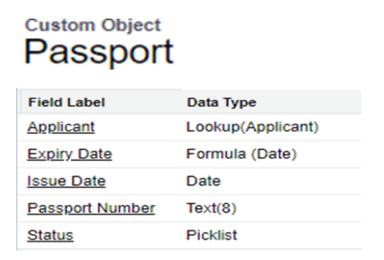

Steps to create Passport object-
Step 1
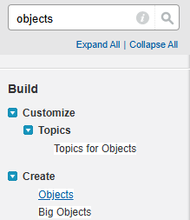
Step 2
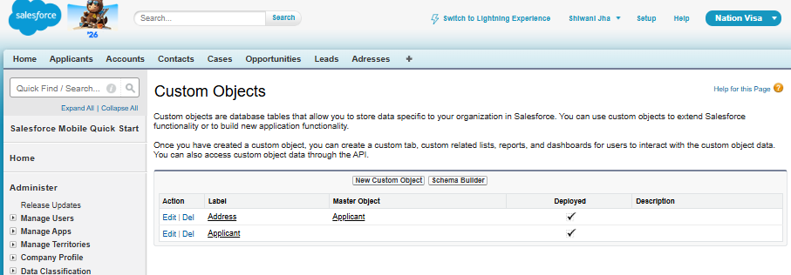
Step 3
Create the Passport object.
Create an Auto Number field.
Set the format as:
PID-{00000}
Enable the required options by ticking the relevant checkboxes.
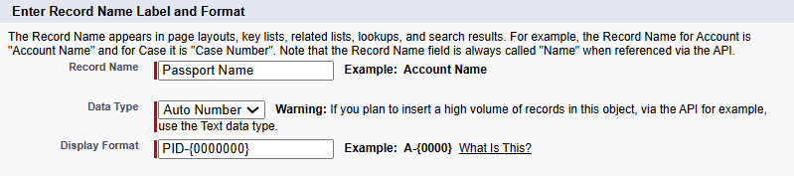
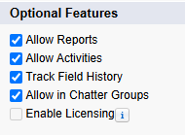
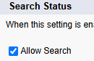
Tick the option to directly object to the tab
And choose the colour to display it
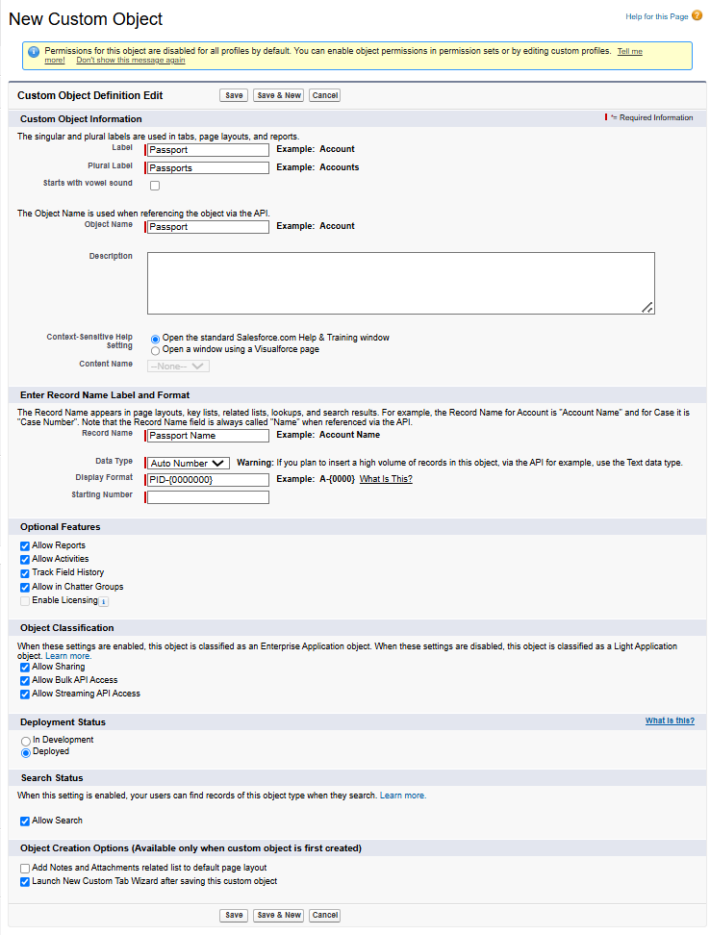
Creating the Lookup Relationship
The relationship is created from the object that will become the Child.
The relationship is created from the object that needs to become the Child.
Here:
Applicant → Parent
Passport → Child
Creating Fields of Passport-
Step 1
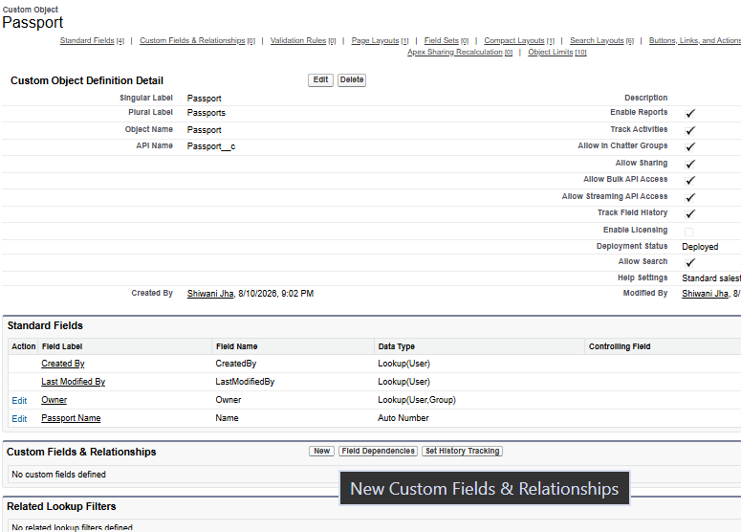
Step 2
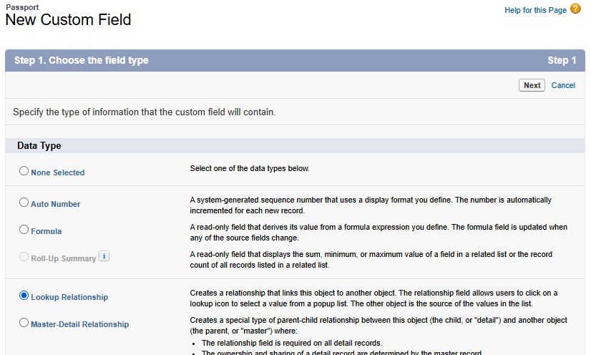
Step 3
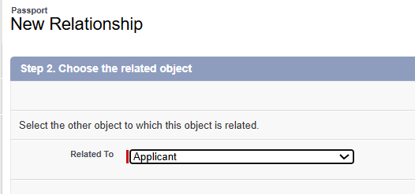
Step 4
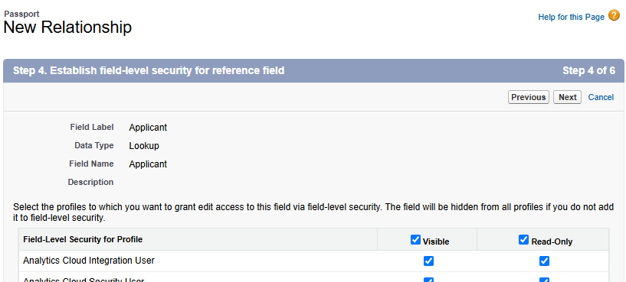
Step 5
Likewise create fields-
- Issue Date – Date
- Expiry Date – Formula Date
- Passport Number – Text (8)
- Status – Picklist
Result-
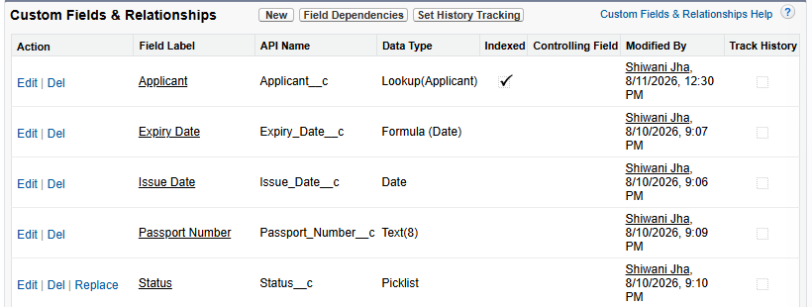

Passport Issue and Expiry Date
We created a formula for the expiry date using:
ADDMONTHS(Issue_Date, 120)
Why 120? - 12 months × 10 years = 120 months
Therefore, the expiry date is calculated as 10 years after the issue date.
Step 1
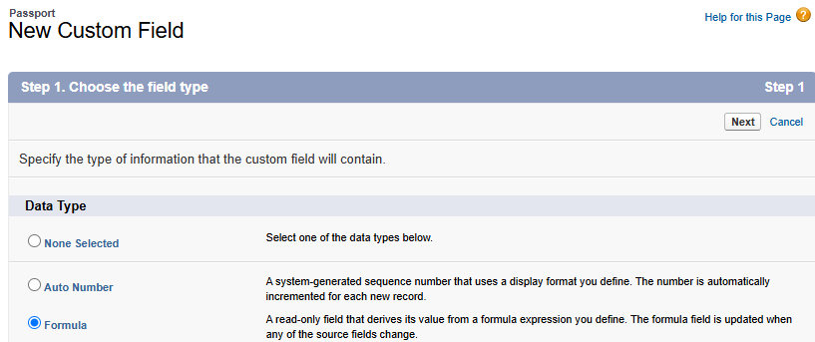
Step 2
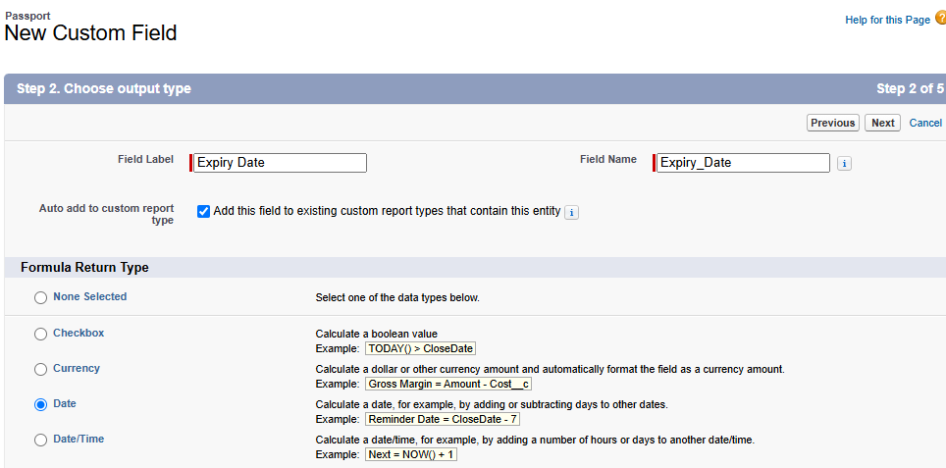
Step 3
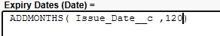
Step 4
Tick visible -> next -> next -> save.
Difference of issue and expiry date- 10yrs
Result-
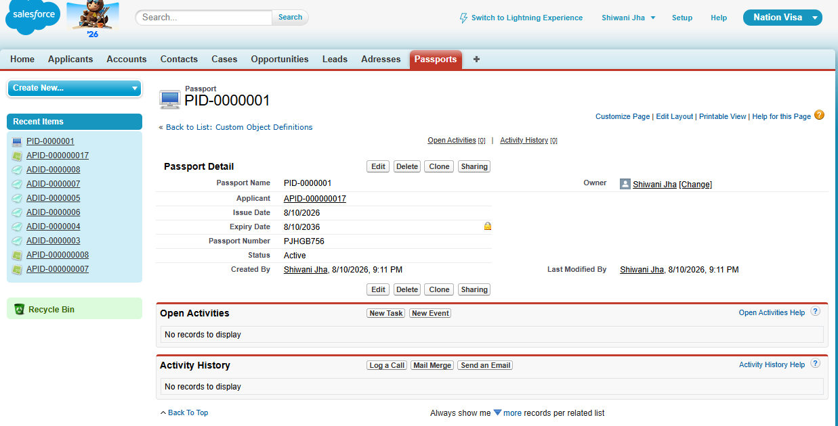

Testing Lookup Relationship
1. Parent is not mandatory
When creating a Passport record, the Applicant/Parent does not have to be assigned.
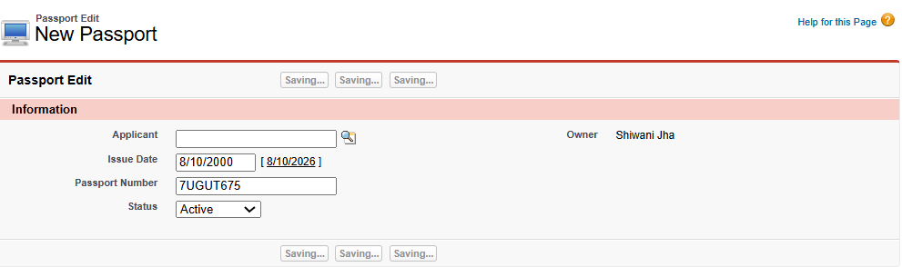
See we can create without giving parent (applicant info)
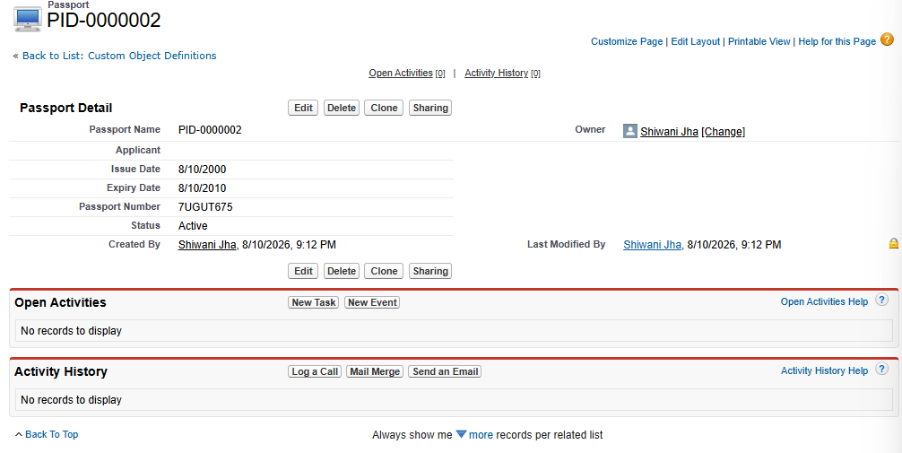

2. Delete the Parent
- Delete the Applicant.
- Check the Passport record.
- The Passport record is not deleted.
- This shows that deleting the Parent does not automatically delete the Child in a Lookup relationship.
Step 1: PID-000001 connected to User APID-0000000015
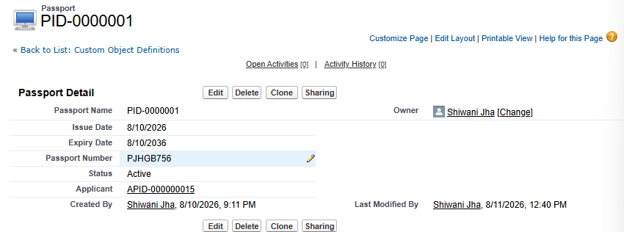

Step 2: Let’s delete the applicant
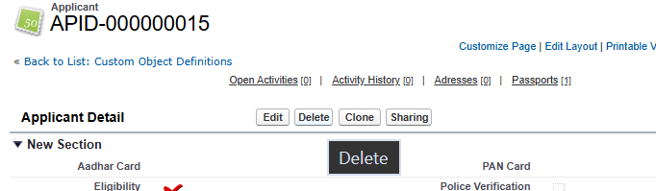

Step 3: Applicant id deleted but Object child (Passport ID is still there)
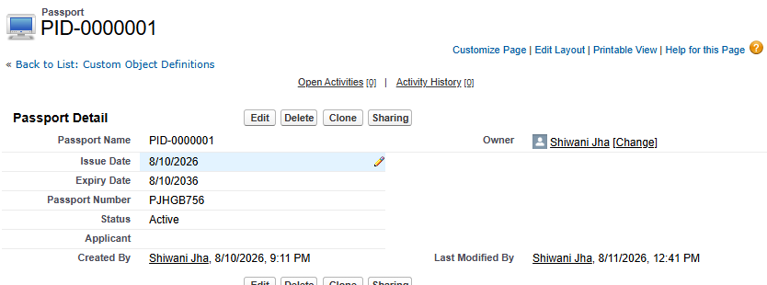

Undelete the Parent
- Go to the Recycle Bin.
- Undelete the Applicant.
- Check the Passport record again.
- The relationship can be assigned again.
Step 1: Click on Recycle bin and undelete the Applicant ID
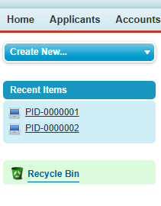
Step 2
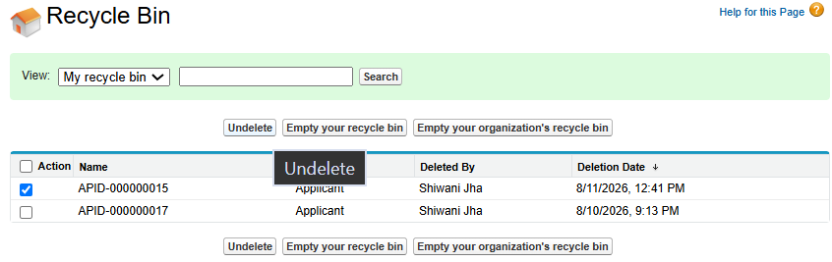
Step 3: It again shows the Applicant id in passport Id.
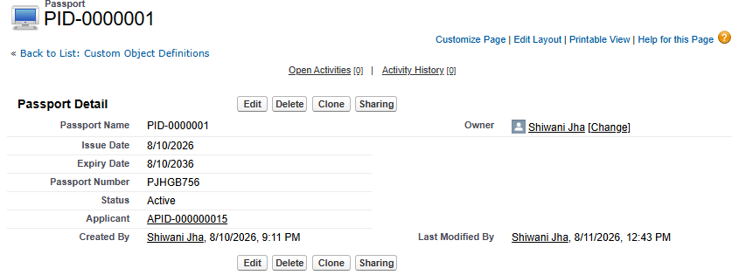

3. Existing Child Records
Even if the Passport object already contains records, we can still create a Lookup relationship.

4. Roll-Up Summary
We tried creating a Roll-Up Summary field with the Lookup relationship.
However, the Roll-Up Summary option is not available, because this is not a Master-Detail relationship.
Step 1: click on “applicant”
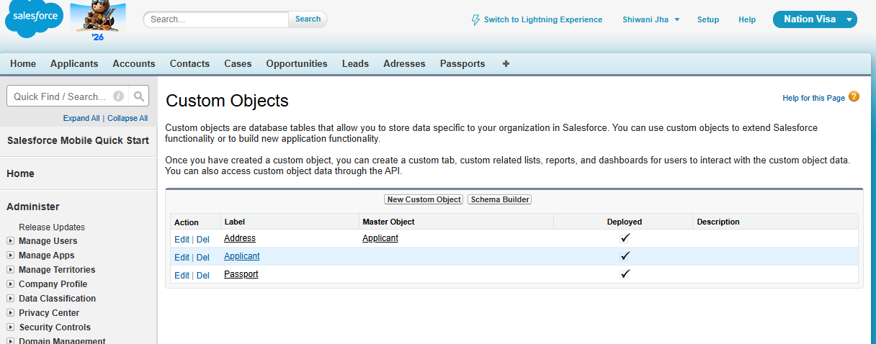

Step 2: Click on “new”
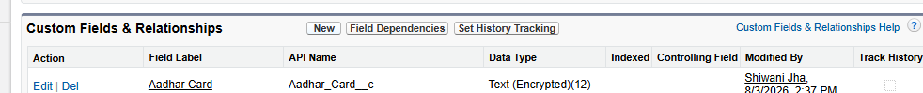
Step 3: Select roll-up summary field
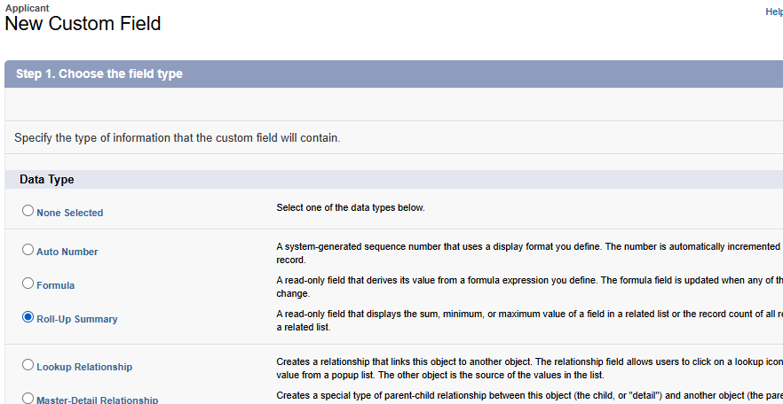
Step 4
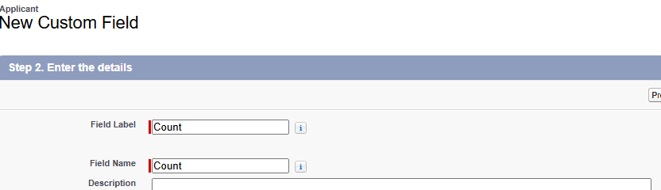
Step 5
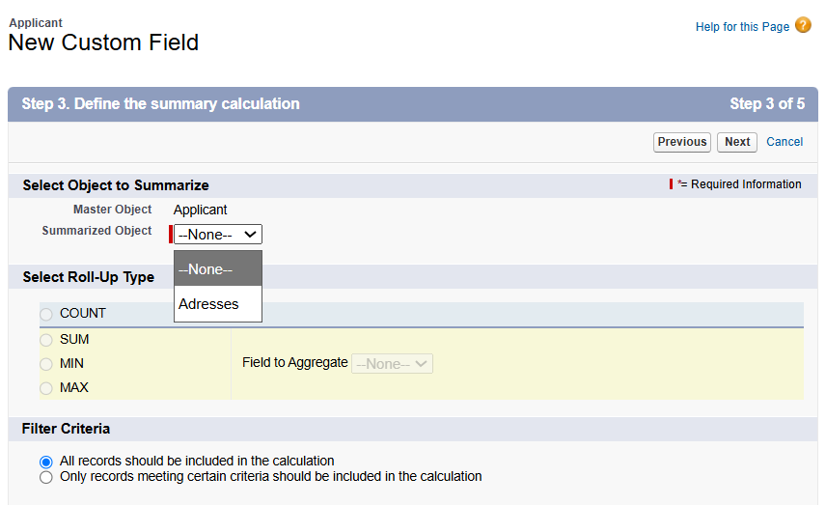
No Passport option is available because it is a Lookup Relationship, and Lookup Relationships do not support Roll-Up Summary fields.

Making Applicant Required
We also made the Applicant field Required.
Important:
Making the Parent field mandatory does not convert a Lookup relationship into a Master-Detail relationship.
Even if the Lookup relationship is made required:
- It is still a Lookup relationship.
- It does not become Master-Detail.
- A Roll-Up Summary field still cannot be created.
Step 1: Make the Applicant field mandatory in the Passport object.
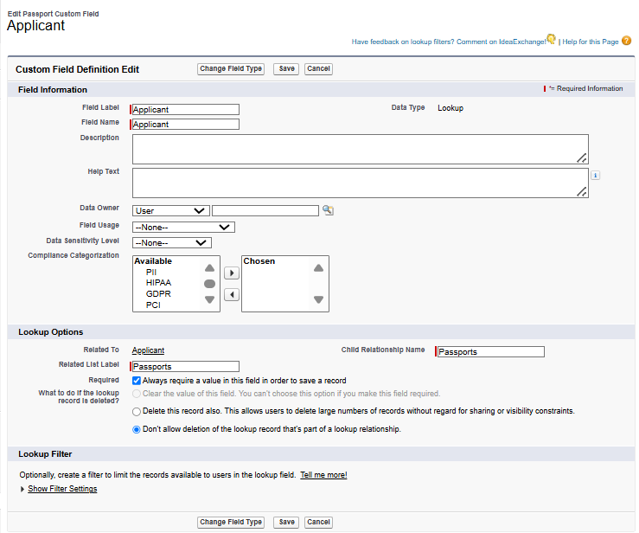
Step 2
Make the applicant field of “passport object” required.
Step 3
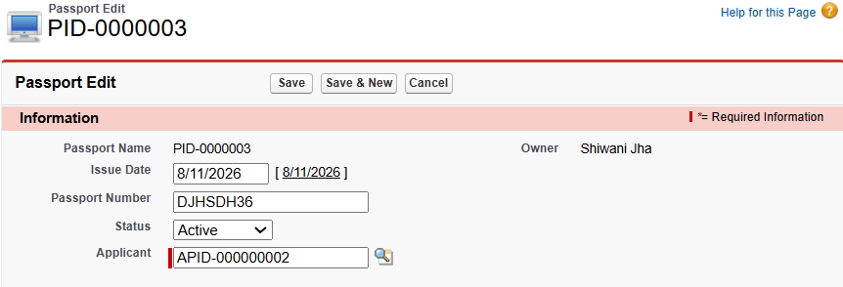
See the applicant is required.
Making the field mandatory does not convert a Lookup relationship into a Master-Detail relationship.
Can making a Lookup relationship mandatory convert it into Master-Detail?
No.
- The relationship will still remain a Lookup Relationship.
- A Roll-Up Summary field cannot be created because Roll-Up Summary is not supported for Lookup relationships.

Master details relationship:
- 1. Master is mandatory while creating details records
- 2. When we delete master record details gets deleted cascading.
- 3. While creating m-d relation, no record exits in detail object
- 4. We can create rollup summary field of master object of detail record.
Lookup relationship
- Object A and object B (Applicant and passport)
- A- parent, B – child
- 1. Parent is not mandatory while creating child record.
- 2. If we delete parent then child not get deleted.
- 3. If child have some records, then also, we can create lookup relationship.
- 4. We can’t create rollup summary field.
Master-Detail vs Lookup Relationship
Important for Mid-Sem: Learn at least 6 differences.
Master-Detail | Lookup
1. Master is mandatory while creating Detail records. | 1. Parent is not mandatory while creating Child records.
2. Deleting the Master deletes the Detail records (cascade delete). | 2. Deleting the Parent does not delete the Child records.
3. Detail records must not already exist when creating the relationship. | 3. Lookup can be created even when Child records already exist.
4. Roll-Up Summary can be created on the Master object. | 4. Roll-Up Summary cannot be created.
5. Detail is strongly dependent on the Master. | 5. Child is not fully dependent on the Parent.
6. Master-Detail provides tighter dependency between the two objects. | 6. Lookup provides a more loosely coupled relationship.

Example 1
Lookup Relationship Example — Account & Contact
We also worked with:
Account → Parent
Contact → Child
Steps:
- Create an Account record.
- Create a Contact record.
- Create/use the Lookup relationship.
- Delete the Account.
- Check the Contact.
The Contact does not behave exactly like a normal Master-Detail child.
Step 1
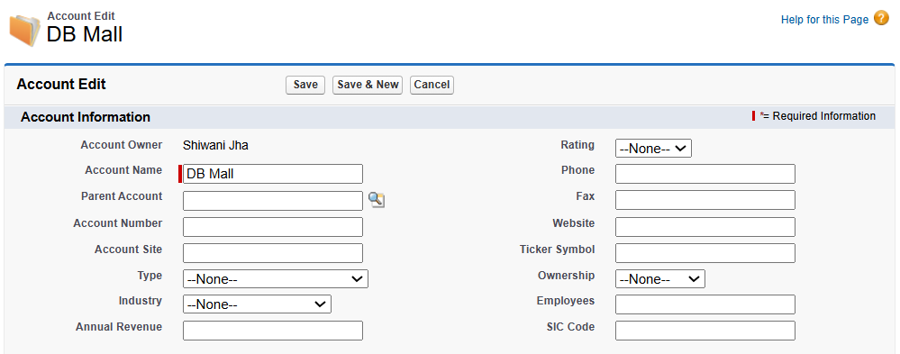
Step 2
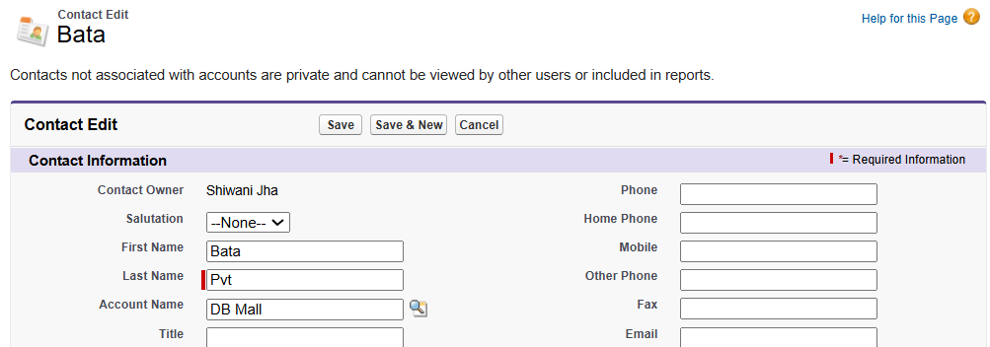
Step 3
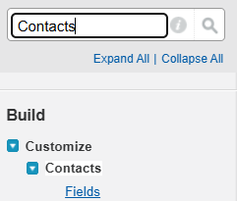
Step 4
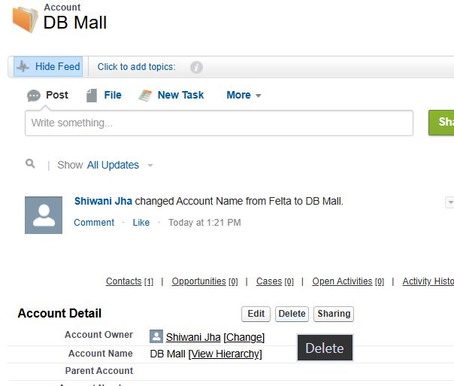
Step 5
Contact is also deleted from “contacts” tab.
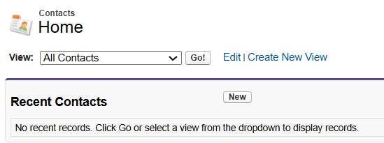
So, although the relationship is shown as a Lookup Relationship, it has some properties of a Master-Detail relationship, such as cascade deletion.
The Contact is also deleted from the “Contacts” tab.
Therefore, although the relationship is shown as a Lookup Relationship, it has some properties of a Master-Detail relationship, such as cascade deletion.

Trying to prove whether Account → Contact supports a Roll-Up Summary.
Follow these exact steps:
Step 1: Open the Account object.
Go to Setup. -> Open Object Manager. -> Select Account -> Fields & Relationships. -> New

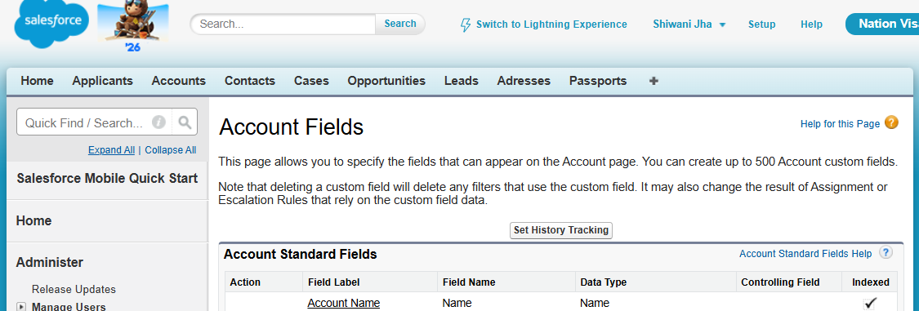
Step 2: Select Roll-Up Summary
Select Roll-Up Summary as the field type. -> Click Next.
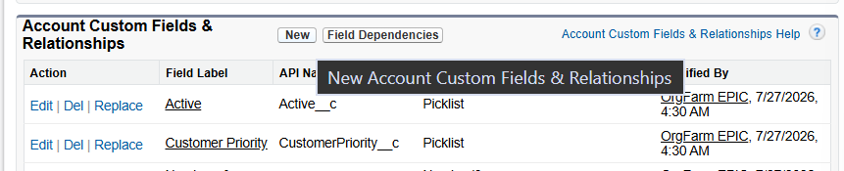
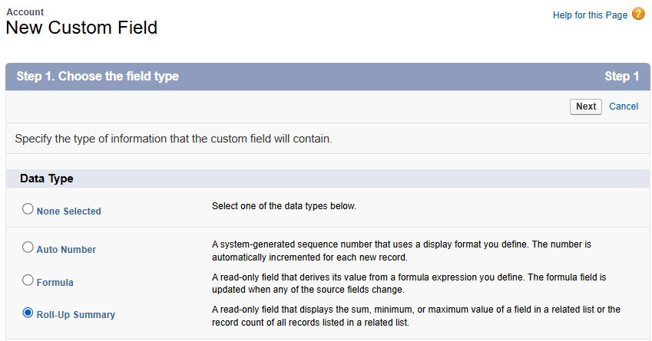
Step 3
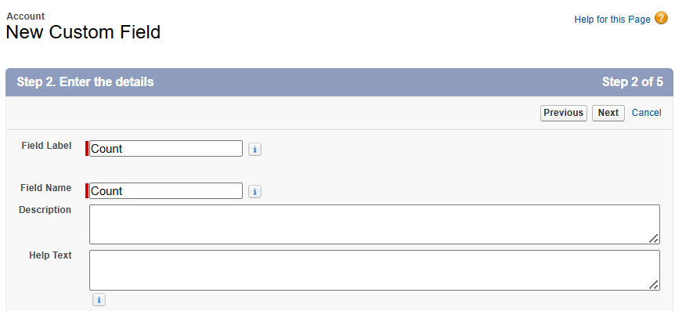
Step 4
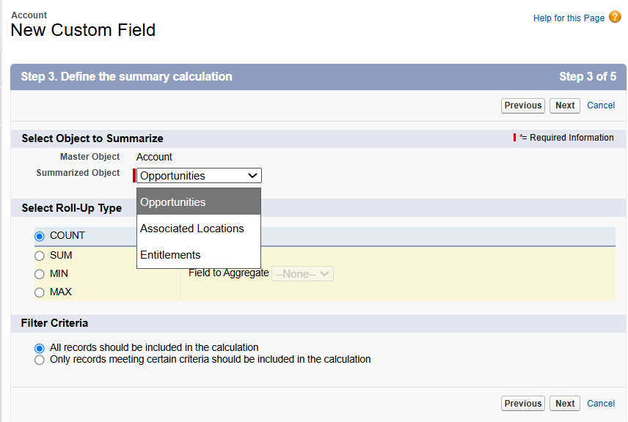

Check the Related Object
Here you would expect to select Contact if Account → Contact was a normal Master-Detail relationship.
Contact is not available as the Detail object.
So, the result is:
Contact option is not available for the Roll-Up Summary field.
This confirms that although Account → Contact has some Master-Detail-like behaviour (such as cascade deletion), it is not a normal Master-Detail relationship.

For Account → Contact, you observed:
- Account deleted → Contact also deleted → this behaves like a Master-Detail property (cascade deletion).
- Roll-Up Summary cannot be created → this behaves like a Lookup relationship property.
So you can think of it as a special/hybrid relationship:
Account–Contact = Lookup relationship with some Master-Detail-like behavior.

Example 2
Account → Opportunity
Account = Parent
Opportunity = Child
you observed two different behaviours:
1. Account is deleted → Opportunity is also deleted
This is a Master-Detail-like property because the Child gets deleted when the Parent is deleted.
2. Roll-Up Summary can be created
This is also a Master-Detail-like property, because Roll-Up Summary is associated with Master-Detail relationships.
3. Master is not mandatory.
That is different from a normal Master-Detail relationship, where the Master is mandatory for the Detail record.

Point 1: Account is deleted → Opportunity is also deleted
Step 1: Create an Account -> Go to Accounts -> Create an Account named DB Mall -> Save it.
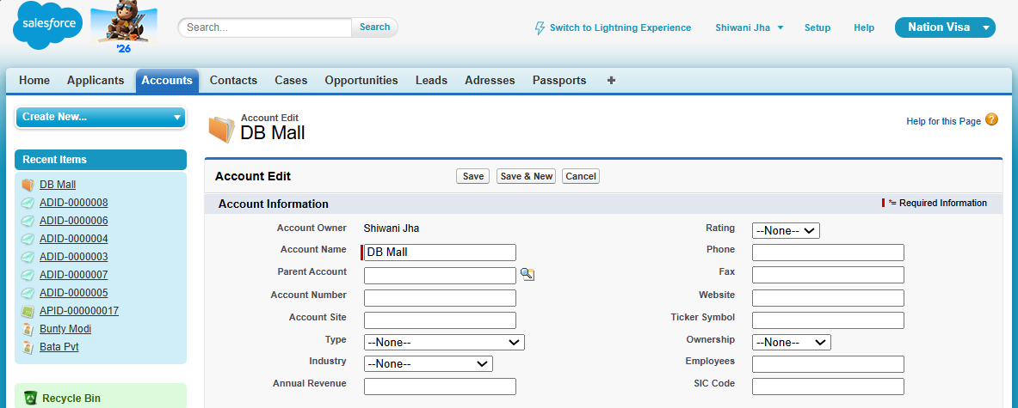
Step 2: Create an Opportunity
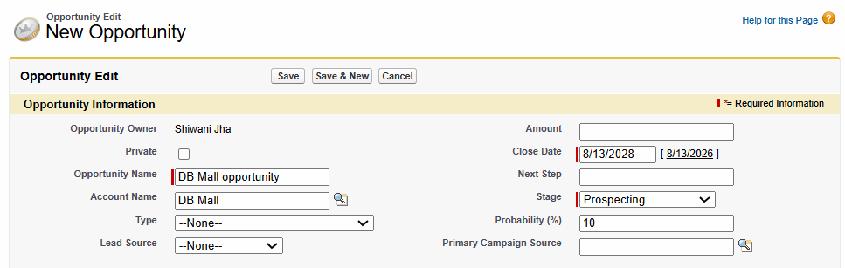
DB Mall (Account) → Opportunity
Step 3: Delete the Account
Go to Accounts -> Open DB Mall -> Click Delete -> Confirm the deletion.
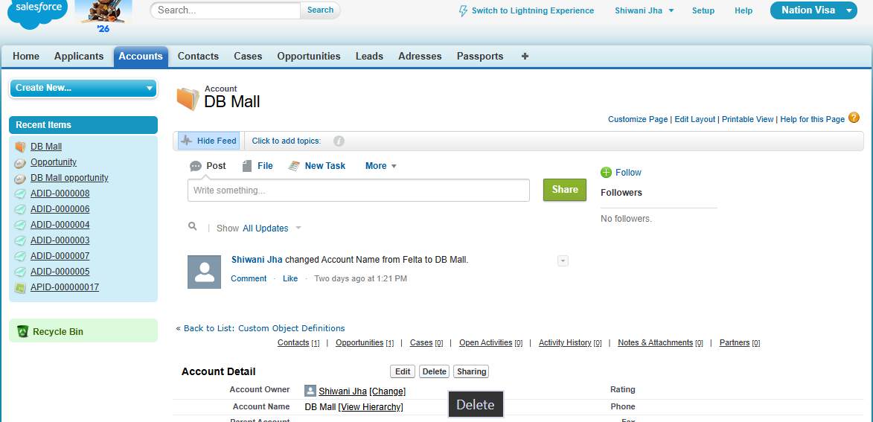
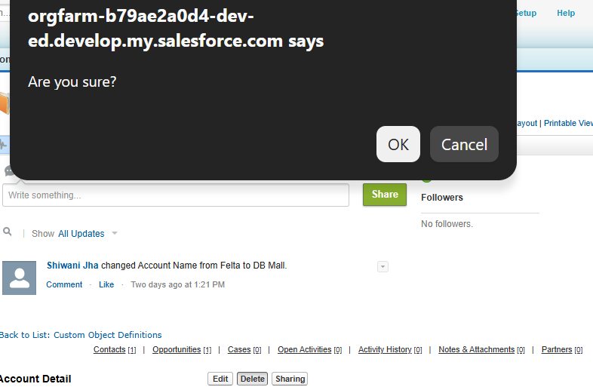
Step 4: Check the Opportunity
DB Mall Opportunity automatically deleted.
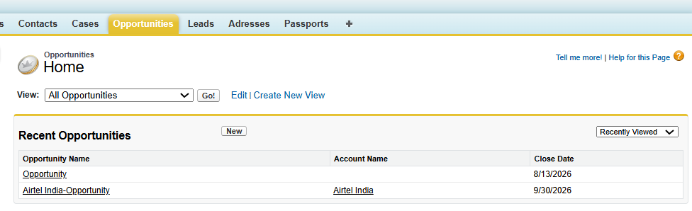
Point 2: Roll-Up Summary can be created.
Step 1
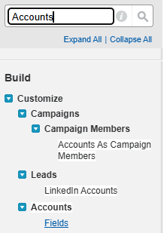
Step 2
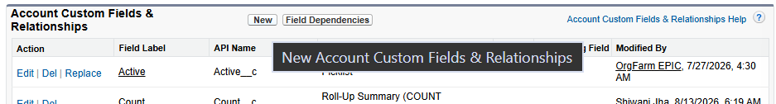
Step 3
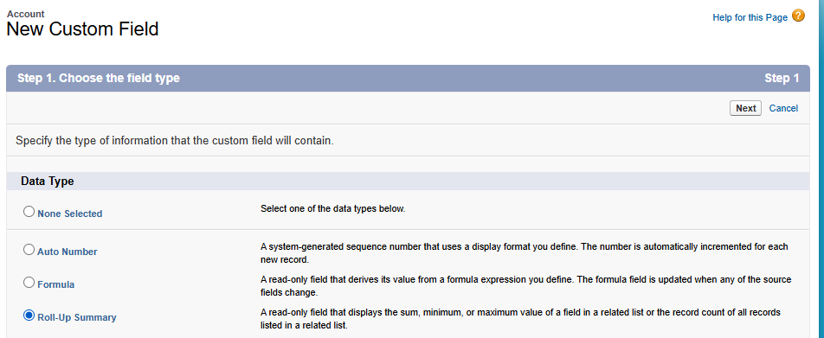
Step 4
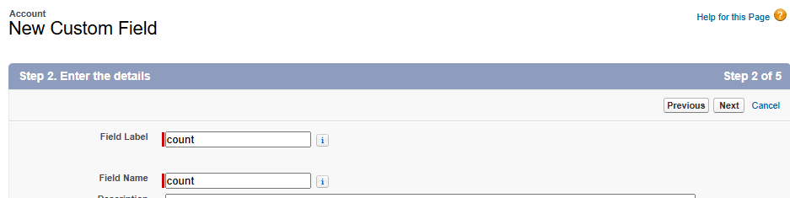
Step 5
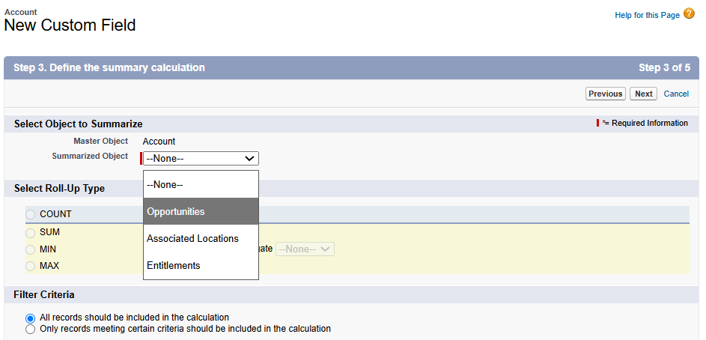
Step 6
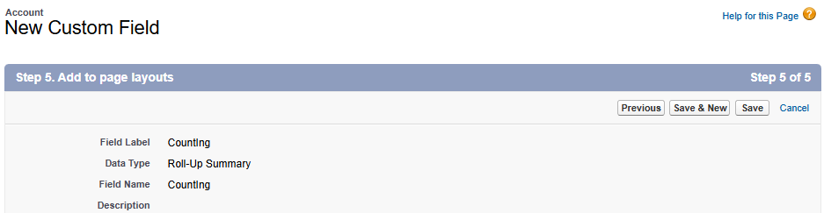
Account (Master) → Opportunity (Detail)
supports a Roll-Up Summary on Account using Opportunity records.

Point 3: Check whether Account is mandatory
Step 1
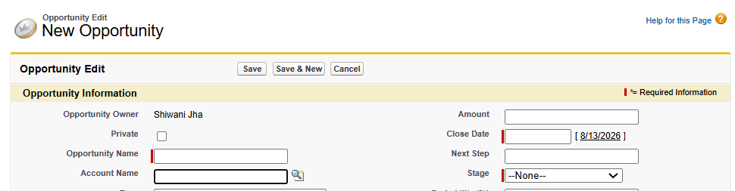
See, “Account Name” is not mandatory
Step 2: Saved It without “Account name” as it is not mandatory.
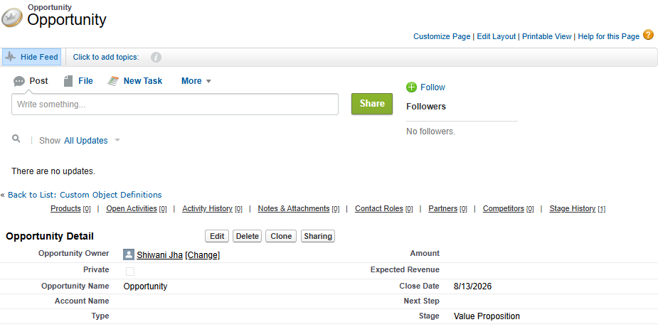
So why did you call it Hybrid?
Because the relationship has some Master-Detail-like behaviour but does not behave exactly like a standard Master-Detail relationship.
You can remember it like this:
Account → Opportunity
- Account deleted → Opportunity deleted = Master-Detail-like
- Roll-Up Summary possible = Master-Detail-like
- Account not mandatory = Not exactly normal Master-Detail = Lookup like
This is why it was discussed as a hybrid/special relationship.

[INTERVIEW QUESTION]
Hybrid relation-
Master detail and lookup mix-up
- Master deletes, child delete
- Can’t create rollup summary
- Account and contacts are in hybrid relationship
- We can’t create this relationship
- Master mandatory Nhi h
- Salesforce ne banake diya h
Hybrid Relationship
We discussed a Hybrid Relationship, which is a mix of some Master-Detail-like and Lookup-like behavior.
Account & Contact
Salesforce provides special behavior for Account and Contact.
Important points from class:
- Deleting the Account can affect the Contact.
- Roll-Up Summary cannot be created in the normal way.
- Account and Contact have a special/hybrid relationship.
- We cannot create this exact relationship ourselves.
- Salesforce provides this relationship.
- The Parent is not necessarily mandatory in the same way as a normal Master-Detail relationship.
Account & Opportunity
We also discussed:
Account → Opportunity
Important points from class:
- Roll-Up Summary can be created in this relationship.
- If the Account is deleted, related Opportunities can also be deleted.
- The Master/Parent is not mandatory in exactly the same way as a normal Master-Detail relationship.

Convert Master-Detail → Lookup
When converting a Master-Detail relationship into a Lookup relationship:
Most important step:
Delete the Roll-Up Summary fields first.
Then convert the relationship.
Step 1
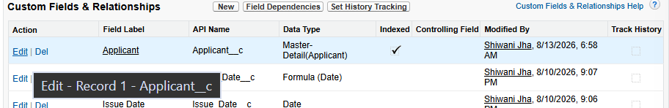
Step 2
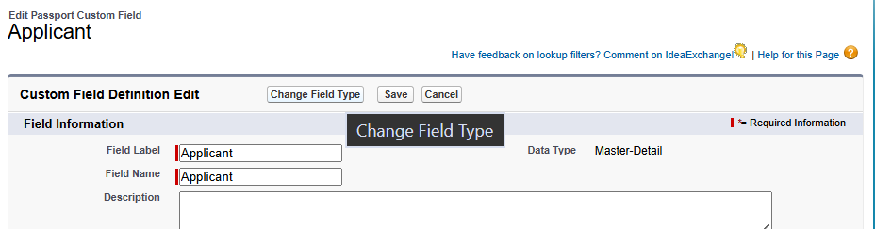
Step 3
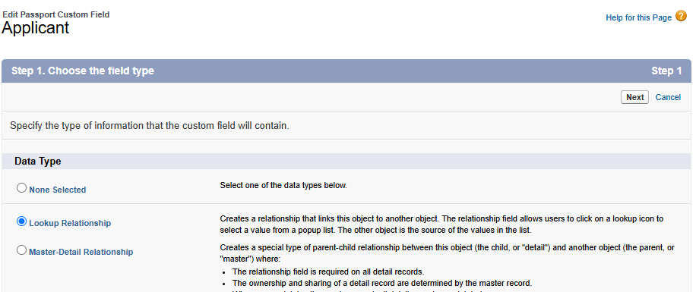
Step 4
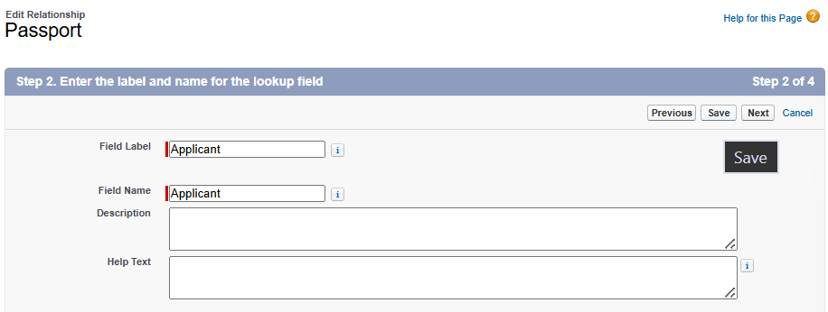
Step 5
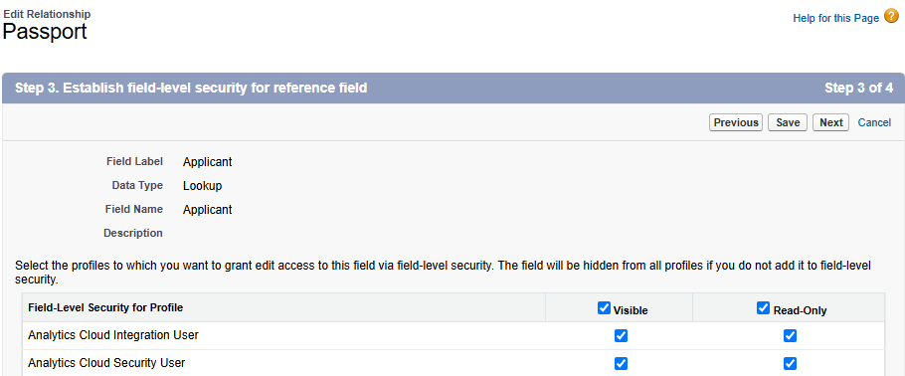
Step 6
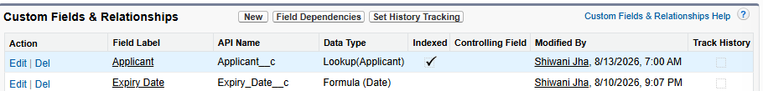
Done!!!

Convert Lookup → Master-Detail
When converting a Lookup relationship into Master-Detail:
- Every Child record must have a Parent assigned.
- Existing Child records cannot be left without a Parent. Assign a Parent to every existing Child record. Then convert the Lookup relationship to Master-Detail.
- This is necessary because the Master becomes mandatory.
Step 1 – Assign parent to every Child
Step 2
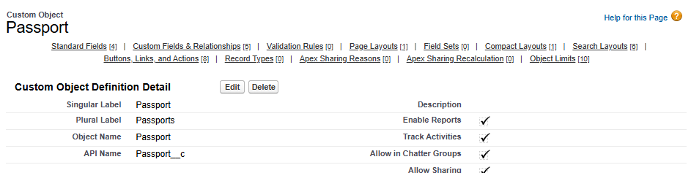
Step 3
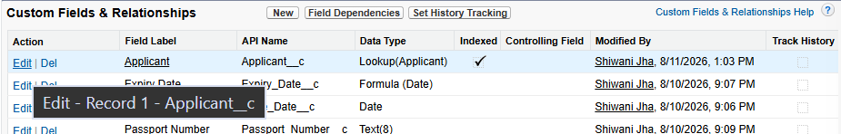

Step 4
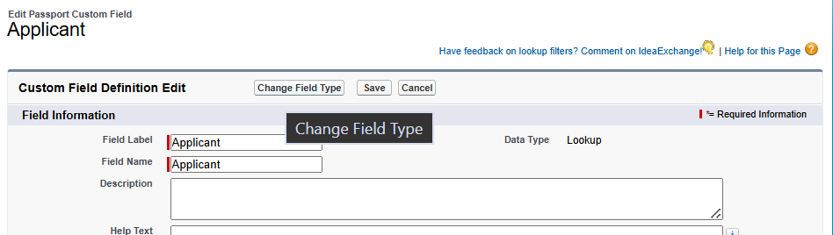
Step 5
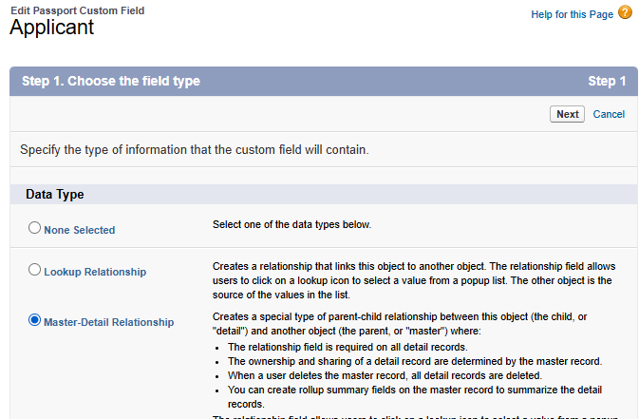
Step 6
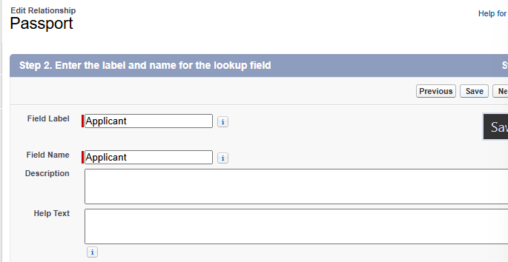
Step 7

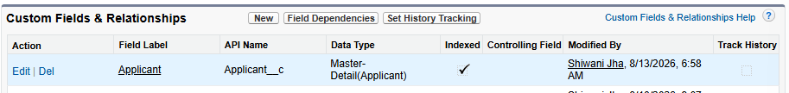
Done!!!!

Important point
If existing Child records do not have a Parent, conversion to Master-Detail will create problems because the Parent becomes mandatory.

Other Topics Mentioned
Topics mentioned at the end of the class:
- Self-Relationship
- Cross Relationship
- Address
These appear to be topics to cover further.

